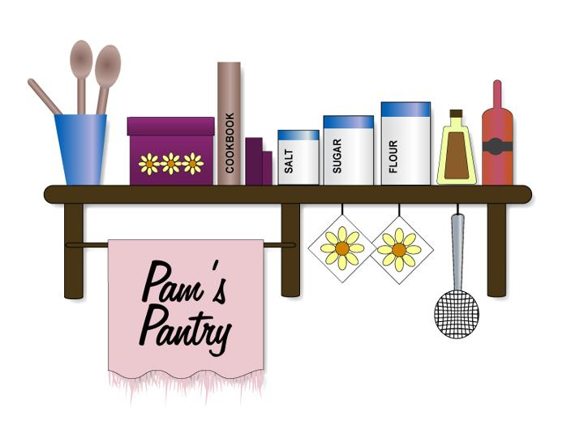
Pam's Pantry
MAIL-IN ORDER FORM
DELECTABLE DIPS / SAVORY
Description | Qty |  | Description | Qty |  | Description | Qty
Bloomin’ Onion |  |  | Garlic & Herb |  |  | Roasted Tomato & Onion
Buffalo Blue Cheese |  |  | Garlic Dill |  |  | Spinach Surprise
Buttermilk Ranch |  |  | Garlic Ranch |  |  | Sweet Chili Dip
Chicken on a Biscuit |  |  | Kaden’s Krabilicious |  |  | Sweet Pepper Garlic
Collin’s Garlic Clove |  |  | Kerry’s Kreamy Kucumber |  |  | Tomato & Garlic
Definitely Dill |  |  | Onion & Horseradish |  |  | Tomato & Horseradish
Everything Bagel |  |  | Outrageous Olive |  |  | Veggie Delite
French Onion |  |  | Pineapple & Peppers
Garlic & Chives |  |  | Roasted Garlic Carmelized Onion
MEAT & CHEESE LOVERS
Description | Qty |  | Description | Qty |  | Description | Qty
Bac’n & Garlic |  |  | Cheddar Ranch |  |  | Hog Heaven (Bacon, Onion, Tomato Garlic)
Bac’n & Horsey |  |  | Cheeseburger Dip |  |  | Hog Wild (Cheesy Bacon & Tomato)
Bac’n & Onion |  |  | Cheesy Bacon |  |  | Italian Cheese Dip
Bac’n & Tomato |  |  | Cheesy Bacon & Onion |  |  | Linda’s Loaded Potato
Bacon Chili Cheese |  |  | Cheesy Garlic |  |  | Old English Pineapple
Bacon Ranch |  |  | Cheesy Garlic & Onion |  |  | Parmesan Onion
Beef Jerky |  |  | Cheesy Tomato Basil |  |  | Pepperjack
Beefy Nacho |  |  | Chili Cheese |  |  | Philly Cheese Steak
Cheddar & Ale |  |  | Ed’s Pizza Pizzazz |  |  | Smoked Cheesy Bacon
Cheddar Dill |  |  | Emma’s Eazy Cheezy w/Horseradish) |  |  | Sweet Vidalia Cheddar
SALSA & SPICE
Description | Qty |  | Description | Qty |  | Description | Qty
Bloody Mary Salsa |  |  | Khory’s Kickin Salsa (mild garden salsa with a hint of garlic) |  |  | Seven Layer Dip
Holy Guacamole |  |  | Mellie’s Mexi Mix (not spicy) |  |  | Sweet & Sassy Salsa
Jalapeno Dip (Spicy Hot) |  |  | Peach Salsa |  |  | Tasha’s Texas Twister-cheesy jalapeno
Jalapeno Popper Dip |  |  | Russ’ Ragin Cajun Garlic |  |  | Tropical Guacamole
FRUIT DIP / NO BAKE CHEESECAKE MIXES
Description | Qty |  | Description | Qty |  | Description | Qty
Banana Cream Pie |  |  | Creamy Caramel |  |  | Raspberry Jalapeno
Britt’s Blueberry Buckle |  |  | Funfetti |  |  | Raspberry Lemonade
Café Latte |  |  | Gingerbread Cookies |  |  | Razzle Dazzle Berry
Caramel Apple Dip |  |  | Just Peachy |  |  | Salted Caramel
Cherry Cheesecake |  |  | Leanne’s Luscious Lime |  |  | Schnozberry
Chocolate Chip Cookie Dip |  |  | Lemon & Blueberries |  |  | Snickerdoodle
Chocolate Covered Berrys |  |  | Lemon Drop |  |  | Strawberries N’ Cream
Chocolate Crème de Menthe |  |  | Peanut Butter Pie |  |  | Tom’s Tropical Treat
Chocolate Cream Pie |  |  | Peanut Butter Chocolate Chip |  |  | White Chocolate Raspberry
Cookies N’ Cream |  |  | Pineapple Passion
Creamsicle Dreamsicle |  |  | Pumpkin Spice
DRESSINGS / MISCELLANEOUS
Description | Qty |  | Description | Qty |  | Description | Qty
Anabelle's Applesauce |  |  | Kara's Krazy Kukes  (Garlic Dill Refrigerator Pickles) |  |  | Right on Ranch Dressing
Dill & Pickle Tarter Sauce |  |  | Mandarin Cranberry Chicken Salad |  |  | Sandy's Super Slaw
Grandma's Icebox Pickles  (Bread & Butter Refrigerator Pickles) |  |  | Perfect Pickler  (Pickled Asparagus & Bologna Mix) |  |  | Sassy Sausage  (Summer Sausage Mix made with burger)
Gudrun's Great Glaze BBQ
CRAZY CRACKERZTM & Bread Dipper Seasonings
Description | Qty |  | Description | Qty |  | Description | Qty
Cheddar & Ale |  |  | Elephant Ears |  |  | White Cheddar Onion
Dill Pickle |  |  | Garlic Galore
Dilly-Licious |  |  | Salt & Vinegar |  |  | Garlic Butter Bread Dipper
SINGLE SERVE SOUPS
Description | Qty |  | Description | Qty |  | Description | Qty
Cheddar & Ale |  |  | Cream of Broccoli |  |  | Pepperjack
Chicken Noodle Soup |  |  | Creamy Potato Bacon |  |  | Tomato Basil White Cheddar

SALE SPECIAL:
Buy 6 mixes, get 1 free – 7 mixes for $30.00 plus only $5 shipping
Buy 10 mixes, get 2 free – 12 mixes for $50.00 plus only $5 shipping

Cost Per Pack  $5.00 each  $5 shipping/handling fee  Shipping is via USPS unless  otherwise specified. Addt. charges may occur. |  | Total # of Packs Ordered _______ X  Cost Per Pack $ 5.00 =  Total Cost of Packs $_______  Shipping Cost $_______  (TBD when shipped, we will invoice this cost if applicable and supply a total cost inc. shipping on invoice)  Thank You For Your Order
Business Name/Name

Address: City: State: Zip Code:

Phone: | Email:
Credit Card Number: Exp. Date: 3 Digit Code

Name on Card: Signature:

Call, EMAIL or FAX order to:
Pam’s Pantry, PO Box 503, Grand Ledge, MI 48837
Phone 517-719-1308 Email: pamspantry@comcast.net Fax 517-925-8465

